Data Science Tool Mastery Project
SQL, Plotly and scikit-learn on Earthquake Data
Data Engineer Internship, Task 4
Name: Santosh | Notebook: Task4_Tool_Mastery.ipynb

1. Introduction
The goal of this task is to master industry-standard data science tools, show that I can use them through practical exercises, and create portfolio pieces. I chose three tools that I had not used in my earlier tasks: SQL (through SQLite), Plotly for interactive visualization, and scikit-learn for machine learning. Together with Pandas, they cover the full path from asking a question, to querying data, to showing it, to modelling it.
To make the three tools work as one story, I used the cleaned earthquake dataset from my Task 3 project: 15,381 real earthquakes of magnitude 4 and above in India and nearby regions from 2000 to October 2026, from the USGS Earthquake Catalog. Every number in this report comes from my own run of the notebook Task4_Tool_Mastery.ipynb in Google Colab.

2. Key Findings
- SQL: I wrote 8 queries covering filtering, grouping, HAVING, CASE WHEN, a subquery, a CTE, and the RANK, SUM OVER and LAG window functions. India has the most earthquakes (5,073) and Afghanistan has the deepest (average 143.4 km).
- By the end of 2005, 4,653 earthquakes (30% of all 27 years) had already been recorded. The jump in 2005 was +1,423 over 2004.
- Plotly: the stacked yearly chart shows what each spike is made of. 2005 is mostly India, Indonesia and Pakistan. 2015 is Nepal (300 earthquakes, with 155 in April and 152 in May). 2025 has Myanmar (120) and a January peak (118) followed by March (86).
- scikit-learn clustering: KMeans grouped the earthquakes into 6 zones that match known regions, such as the Hindu Kush, the Himalaya and the Andaman and Nicobar arc. Only the Hindu Kush zone is deep (average 115 km).
- scikit-learn classification: a Random Forest predicts whether an earthquake is deep or shallow with 94.5% accuracy, against 72.6% for a model that always guesses shallow. On a harder time-based test (train on 2000 to 2018, test on 2019 to 2026) it scores 94.2% against a 66.5% baseline.
- The model works almost entirely from location: latitude (0.496) and longitude (0.473) make up 97% of the importance, while magnitude is only 0.031. This is classification of depth from location, not earthquake prediction.

3. Tools Selected
All work was done in Google Colab, which gives a ready Jupyter environment in the browser with no installation. SQLite is built into Python, so no separate database software is needed.
Tool | Version | Used for | Why it matters
Python (Google Colab) | 3.13.18 | Running all the code | Standard language for data science
SQL (SQLite) | 3.45.1 | Querying the data: filters, groups, window functions | SQL is the most common skill in data jobs
Pandas and NumPy | 2.2.3 and 2.1.3 | Loading, cleaning and preparing data | Core data analysis libraries
Plotly Express | 5.24.1 | Interactive charts, maps and animation | Used for dashboards and reports
scikit-learn | 1.6.1 | Clustering and classification models | Industry-standard machine learning library

The notebook starts by printing the version of every tool, which confirms that the environment is ready.

4. Data and Preparation
The notebook loads the earthquake data from my GitHub repository (the Task 3 folder), and if that fails it asks for a file upload. It then repeats the key cleaning steps from Task 3: it keeps only real earthquakes, removes duplicate event ids, converts the time column, and creates the year, month and country columns. The country is the text after the last comma in the place description, and small countries (fewer than 50 earthquakes) are grouped as Other. The result has 15,381 rows.

4.1 A correction I made in this task
While cross-checking SQL results against my Task 3 numbers, I found two records whose place text is an event name, not a normal location: '2025 Mandalay, Burma (Myanmar) Earthquake' (magnitude 7.7) and '2025 Southern Tibetan Plateau Earthquake' (magnitude 7.1). The first version of the country column put them into Other. I added a small function to clean them, which moves them to Myanmar and China. As a result, Myanmar now has 1,248 earthquakes with a maximum of 7.7, China has 1,755 and Other has 169.
Code
# fix records whose place text is an event name, e.g. "2025 Mandalay, Burma (Myanmar) Earthquake"
def fix_country(text):
text = text.replace(" Earthquake", "").strip() # remove the word Earthquake
text = text.lstrip("0123456789 ") # remove a leading year
return country_fix.get(text, text)

df["country"] = df["country"].apply(fix_country)

I also defined the strength classes with a clear rule (6.0 and above counts as Strong). One aftershock of magnitude 5.95 (26 December 2004) is therefore Moderate, which gives Strong 100 and Moderate 1,635, and is consistent with the 115 earthquakes of magnitude 6 and above (100 Strong plus 15 Major).

5. SQL Analysis
I loaded the data into an in-memory SQLite database and wrote a small helper function that runs a query and returns a Pandas table. This is a common pattern for running SQL inside a Python analysis.
Code
import sqlite3
import pandas as pd

# create a small database in memory and load the table into it
conn = sqlite3.connect(":memory:")
df.to_sql("earthquakes", conn, index=False, if_exists="replace")

# helper: run a SQL query and show the result as a table
def run(sql):
return pd.read_sql_query(sql, conn)

The database table has 25 columns and 15,381 rows. Then I wrote 8 queries, each using a different SQL concept:
# | SQL concept | Question | Result
1 | SELECT, ORDER BY, LIMIT | Which are the 5 strongest earthquakes? | 7.8 Southern Qinghai (2001) and 7.8 Nepal (2015), then 7.7 Bhachau (2001), 7.7 Mandalay (2025), 7.6 Muzaffarabad (2005)
2 | GROUP BY, aggregates | How do countries compare? | India has the most (5,073); Afghanistan is the deepest (average 143.4 km)
3 | HAVING | Which years had over 600 earthquakes? | 2005 (2,294), 2004 (871), 2008 (869), 2015 (816), 2025 (694), 2006 (634)
4 | CASE WHEN | How many earthquakes in each strength class? | Light 13,631; Moderate 1,635; Strong 100; Major 15
5 | Subquery | How many India earthquakes are stronger than the overall average magnitude? | 2,664 of 5,073 (52.5%)
6 | CTE and RANK() window function | What are the top 3 strongest earthquakes in each country? | See the table below
7 | SUM() OVER (running total) | How do the counts add up year by year? | 4,653 by the end of 2005, which is 30% of all 27 years
8 | LAG() window function | Which year jumped the most from the previous year? | 2005 (+1,423), then 2004 (+559), 2008 (+333), 2025 (+235), 2015 (+218)

5.1 Summary by country (exercise 2)
Country / region | Quakes | Avg mag | Max mag | Avg depth (km)
India | 5,073 | 4.54 | 7.7 | 32.9
Afghanistan | 3,658 | 4.37 | 7.5 | 143.4
China | 1,755 | 4.51 | 7.8 | 19.5
Indonesia | 1,551 | 4.61 | 7.2 | 32.4
Myanmar | 1,248 | 4.50 | 7.7 | 48.7
Pakistan | 999 | 4.49 | 7.6 | 22.9
Nepal | 773 | 4.47 | 7.8 | 16.1
Other | 169 | 4.47 | 6.6 | 50.0
Bangladesh | 78 | 4.44 | 5.7 | 21.2
Tajikistan | 77 | 4.33 | 6.2 | 106.3

India has the most earthquakes, followed by Afghanistan. Afghanistan averages 143.4 km in depth because of the deep Hindu Kush earthquakes, while Nepal (16.1 km), China (19.5 km) and Pakistan (22.9 km) are mostly shallow. Indonesia has the highest average magnitude (4.61), though the differences in average magnitude between countries are small.

5.2 Strongest earthquake in each country (exercise 6)
This query uses a common table expression (CTE) with RANK() OVER (PARTITION BY ...), which ranks the earthquakes inside each country. The table below shows the top-ranked earthquake for each group (the query itself returns the top 3 for each).
Code
# 6. CTE + WINDOW FUNCTION: top 3 strongest quakes in each country
run("""
WITH ranked AS (
SELECT country_group, substr(time, 1, 10) AS date, mag, place,
RANK() OVER (PARTITION BY country_group ORDER BY mag DESC) AS rnk
FROM earthquakes
)
SELECT country_group, date, mag, place
FROM ranked
WHERE rnk <= 3
ORDER BY country_group, rnk
""")

Country / region | Date | Mag | Place
Afghanistan | 2015-10-26 | 7.5 | Hindu Kush region
Bangladesh | 2003-07-26 | 5.7 | 44 km SE of Khagrachhari
China | 2001-11-14 | 7.8 | Southern Qinghai
India | 2001-01-26 | 7.7 | 17 km NW of Bhachau (Gujarat)
Indonesia | 2004-12-26 | 7.2 | 284 km WNW of Sabang
Myanmar | 2025-03-28 | 7.7 | Mandalay
Nepal | 2015-04-25 | 7.8 | 67 km NNE of Bharatpur
Pakistan | 2005-10-08 | 7.6 | 21 km NNE of Muzaffarabad
Tajikistan | 2018-05-09 | 6.2 | 36 km NW of Ishqoshim
Other | 2004-04-05 | 6.6 | Afghanistan-Tajikistan-Pakistan region

5.3 Year-over-year change (exercise 8)
LAG() looks at the previous row, so it can calculate the change from the previous year without a self-join.
Code
# 8. LAG: change from the previous year
run("""
WITH yearly AS (
SELECT year, COUNT(*) AS quakes
FROM earthquakes
GROUP BY year
)
SELECT year, quakes,
quakes - LAG(quakes) OVER (ORDER BY year) AS change_from_last_year
FROM yearly
ORDER BY change_from_last_year DESC
LIMIT 5
""")

The result matches the pattern I found in Task 3: the largest jumps are 2005 (+1,423) and 2004 (+559), followed by 2008, 2025 and 2015. The running total in exercise 7 adds another view: 4,653 earthquakes were recorded in the first 6 years (2000 to 2005), which is 30% of the 27-year total.

6. Interactive Visualization with Plotly
I used Plotly Express to create six interactive charts. In the notebook, each chart supports hovering to see details (place, date, depth, magnitude), zooming and panning, and clicking on legend items, and the animated map has a play button. The images below are static snapshots of those charts.

6.1 Map of strong earthquakes (magnitude 5 and above)
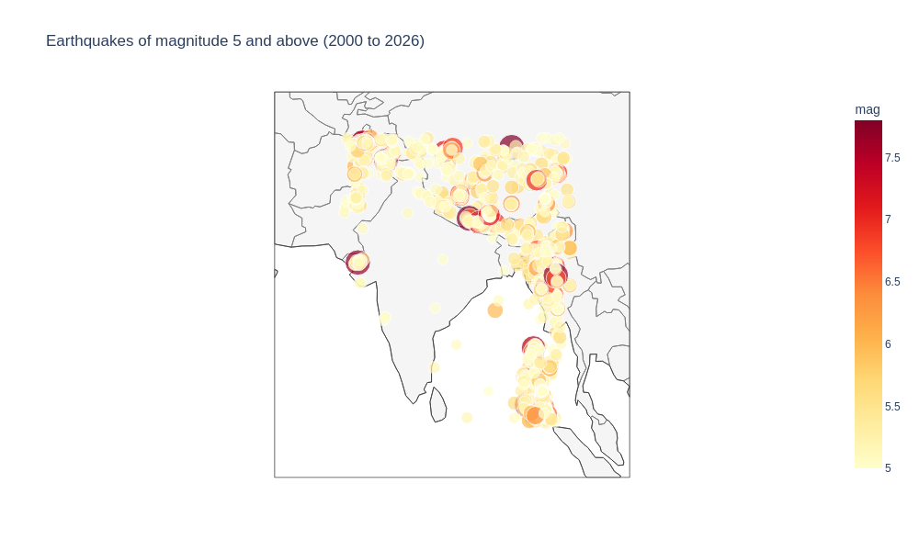
Figure 1: Earthquakes of magnitude 5 and above, 2000 to 2026
The map shows only magnitude 5 and above, so that it stays readable. Larger and darker dots are stronger. The earthquakes follow the plate boundaries: the Hindu Kush at the top left, the Himalayan arc, the Indo-Myanmar ranges, and the Andaman and Nicobar region at the bottom. A large dot in Gujarat marks the 2001 Bhachau earthquake, and the interior of peninsular India has very few strong events.

6.2 Earthquakes per year, split by country
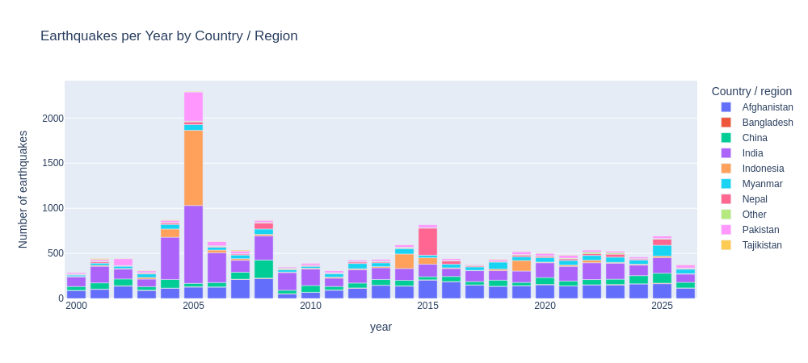
Figure 2: Earthquakes per year by country or region
Splitting each year by country shows what built the spikes. In 2005 India (863), Indonesia (834) and Pakistan (323) dominate. In 2015, Nepal has 300 earthquakes, with 155 in April and 152 in May, and the strongest event of the year was the magnitude 7.8 Nepal earthquake on 25 April. In 2025, Myanmar has 120 earthquakes, and January (118) and March (86) are the busiest months, which fits the Tibetan Plateau (magnitude 7.1, 7 January) and Mandalay (magnitude 7.7, 28 March) earthquakes. In 2008 (869), the count is spread across India (267), Afghanistan (219) and China (201) and across several months, so it is not one single sequence.

6.3 Country and strength (sunburst chart)
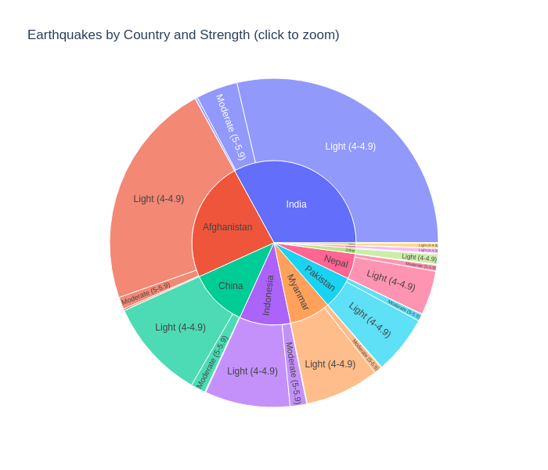
Figure 3: Earthquakes by country and strength
The inner ring shows the country and the outer ring shows the strength class. In the notebook, clicking a country zooms into it. In every country, most earthquakes are Light (magnitude 4 to 4.9), and the Strong and Major classes are too small to see at this size, which shows how rare strong earthquakes are.

6.4 Depth by country
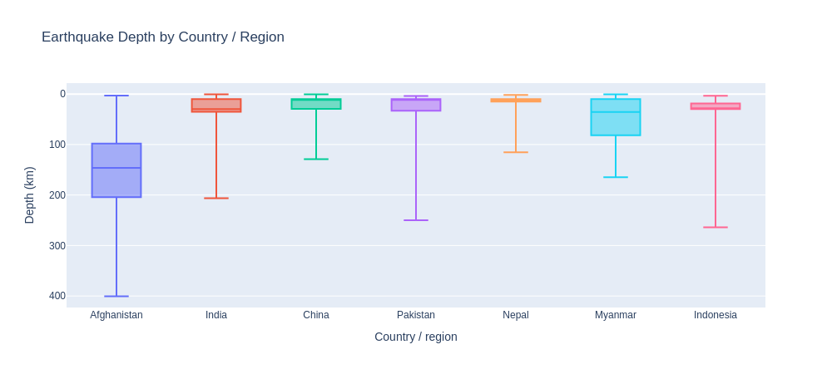
Figure 4: Earthquake depth by country or region
Depth is drawn downwards, like real depth. Afghanistan stands apart, with a median depth of about 146 km. Nepal's box is almost flat at about 10 km. This is because 66% of Nepal's earthquakes have a depth of exactly 10.0 km, which is a default value that USGS uses when the depth is not well measured. Across the whole dataset, 29.0% of depths are exactly 10.0 km and 4.3% are exactly 33.0 km, so depth results should be read as approximate.

6.5 Density heatmap of hotspots
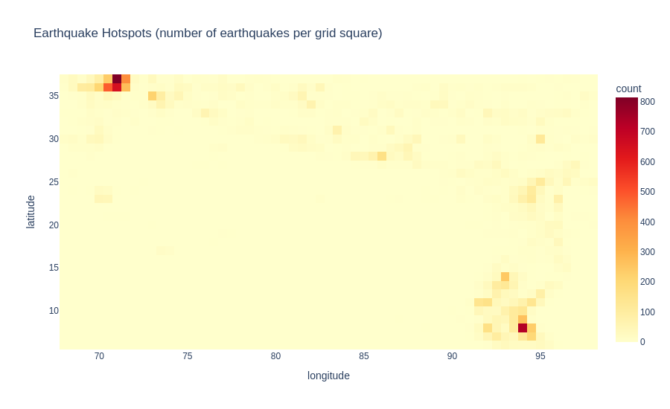
Figure 5: Earthquake hotspots (earthquakes per grid square)
The heatmap counts earthquakes in grid squares about half a degree wide (roughly 55 km). The two hottest squares are in the Hindu Kush (top left, around 36 to 37 degrees north, 70 to 71 degrees east) and in the Andaman Sea and Sumatra region (bottom right, around 7 to 8 degrees north, 94 degrees east), each with roughly 800 earthquakes in a single square. The rest of the map is mostly pale, which means that earthquakes are highly concentrated in a few places.

6.6 Animated map by year
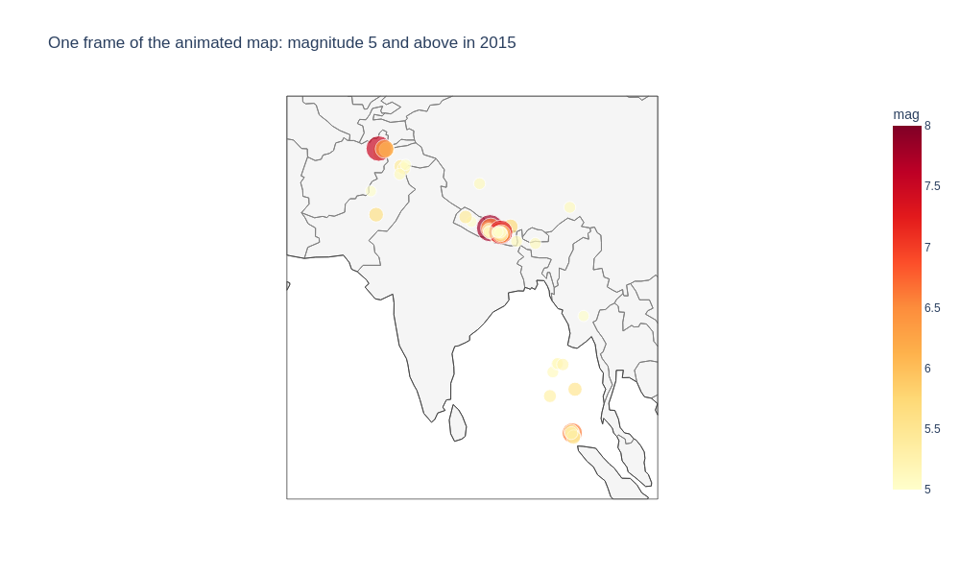
Figure 6: One frame of the animated map (magnitude 5 and above in 2015)
The last chart is an animated map, with one frame for each year and a play button. The figure shows the 2015 frame, which has 70 earthquakes of magnitude 5 and above. The Nepal cluster in the centre is clear, with the Hindu Kush earthquake in the top left and a few events in the Andaman region. In the notebook, the play button steps through all 27 years, so any two years can be compared on the same map.

7. Machine Learning with scikit-learn

7.1 Clustering earthquakes into zones (KMeans)
KMeans is an unsupervised method: I do not give it any labels. It only gets the latitude and longitude of each earthquake and groups nearby earthquakes into zones. I tried different numbers of zones (k) and compared the inertia (how tight the groups are) and the silhouette score (how well separated they are).
Code
from sklearn.cluster import KMeans
from sklearn.metrics import silhouette_score

coords = df[["latitude", "longitude"]]

# try different numbers of zones (k) and compare the scores
for k in range(3, 10):
model = KMeans(n_clusters=k, random_state=42, n_init=10)
labels = model.fit_predict(coords)
score = silhouette_score(coords, labels, sample_size=3000, random_state=42)
print(k, round(model.inertia_), round(score, 3))

# k = 6 zones
kmeans = KMeans(n_clusters=6, random_state=42, n_init=10)
labels = kmeans.fit_predict(coords)
df["zone"] = ["Zone " + str(z + 1) for z in labels]

Output
k inertia silhouette
3 336359 0.69
4 215691 0.669
5 172025 0.66
6 134967 0.659
7 111968 0.587
8 88665 0.587
9 78968 0.561

The silhouette score is highest at k = 3 (0.690) but stays close to that value up to k = 6 (0.659) and then drops clearly to 0.587 at k = 7. I chose k = 6, the largest value before the drop, because it gives more detailed and more useful zones than 3 while still keeping well-separated groups.
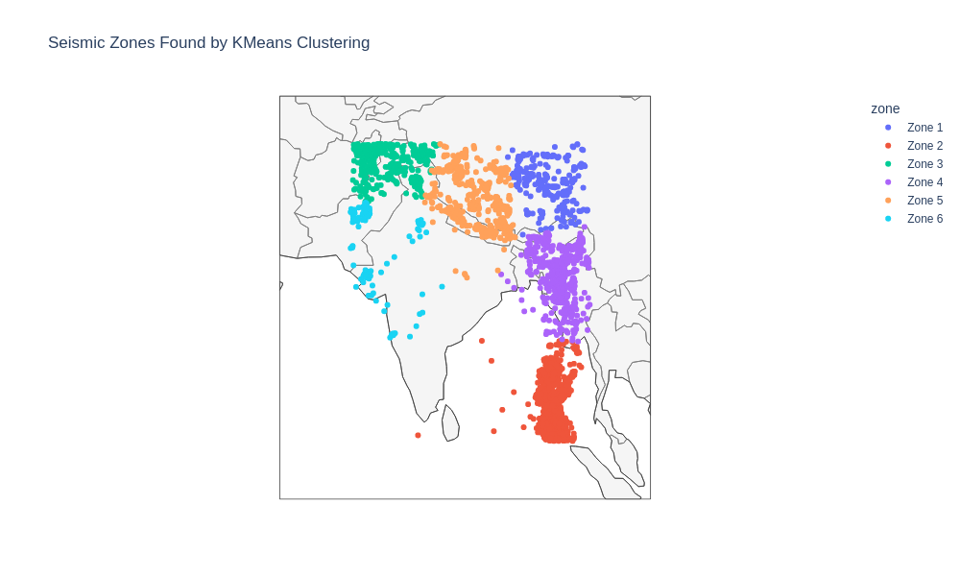
Figure 7: Seismic zones found by KMeans (5,000 random earthquakes shown)
Zone | Quakes | Centre (lat, lon) | Avg mag | Avg depth (km) | Main countries | Likely area (my reading)
1 | 1,017 | 32.39, 93.22 | 4.55 | 19.6 | China 788, India 207 | Central Tibetan Plateau
2 | 4,977 | 9.76, 93.44 | 4.58 | 30.5 | India 3,244, Indonesia 1,551, Myanmar 162 | Andaman, Nicobar and north Sumatra
3 | 4,938 | 35.90, 71.56 | 4.40 | 115.3 | Afghanistan 3,658, Pakistan 801, India 308 | Hindu Kush and Pamir
4 | 2,067 | 23.42, 94.43 | 4.49 | 52.1 | Myanmar 1,086, India 845, Bangladesh 78 | Indo-Myanmar ranges
5 | 1,947 | 30.92, 84.11 | 4.48 | 17.9 | China 910, Nepal 773, India 237 | Himalaya and southern Tibet
6 | 435 | 25.73, 70.84 | 4.46 | 14.7 | India 232, Pakistan 198 | Gujarat to Sindh (west)

The last column is my own reading, based on the centre of each zone and its mix of countries, and the algorithm did not give these names. Key points:
- Zone 3 (Hindu Kush and Pamir) is the only deep zone, with an average depth of 115.3 km. All other zones average between 14.7 and 52.1 km.
- Zone 2 is the largest (4,977 earthquakes). It contains all 1,551 of Indonesia's earthquakes and 3,244 of India's.
- Zone 6 is the smallest (435), but its maximum magnitude is 7.7, the 2001 Bhachau earthquake. A small number of earthquakes can still hide a very strong one.
- Zones 1 and 5 have the highest maximum magnitude (7.8): Southern Qinghai in Zone 1, and Nepal in Zone 5.

7.2 Classification: predicting deep or shallow earthquakes
The second task is supervised learning. I created a target called is_deep, which is 1 when the depth is 70 km or more. 27.4% of earthquakes are deep. The inputs are latitude, longitude and magnitude. I split the data into 80% for training and 20% for testing, and compared three models. The baseline model always predicts shallow, so a real model needs to beat 72.6%.
Code
# target: 1 = deep earthquake (70 km or more), 0 = shallow
df["is_deep"] = (df["depth"] >= 70).astype(int)
features = ["latitude", "longitude", "mag"]
X = df[features]
y = df["is_deep"]

# split: 80% to train the model, 20% to test it
X_train, X_test, y_train, y_test = train_test_split(
X, y, test_size=0.2, random_state=42, stratify=y)

models = {
"Baseline (always predict shallow)": DummyClassifier(strategy="most_frequent"),
"Logistic Regression": make_pipeline(StandardScaler(), LogisticRegression(max_iter=1000)),
"Random Forest": RandomForestClassifier(n_estimators=100, random_state=42, n_jobs=-1),
}

for name, model in models.items():
model.fit(X_train, y_train)
pred = model.predict(X_test)
print(name, accuracy_score(y_test, pred), f1_score(y_test, pred, zero_division=0))

Model | Accuracy | F1 (deep class)
Baseline (always predict shallow) | 0.726 | 0.000
Logistic Regression | 0.839 | 0.711
Random Forest | 0.945 | 0.898

Logistic Regression improves on the baseline (83.9%), but the Random Forest is much better (94.5%). This makes sense because deep earthquakes occur in specific regions such as the Hindu Kush, and a straight-line model cannot separate several separate regions on a map as well as a Random Forest, which can build up many small boxes on the map.

7.3 Checking the Random Forest properly
Output
precision recall f1-score support

Shallow 0.95 0.97 0.96 2233
Deep 0.92 0.88 0.90 844

accuracy 0.95 3077

Time-based test (2019-2026):
Random Forest accuracy: 0.942
Baseline accuracy : 0.665

 | Predicted shallow | Predicted deep
Actual shallow | 2,169 | 64
Actual deep | 104 | 740

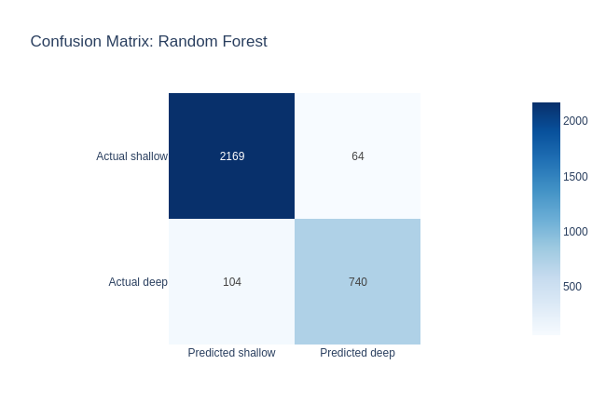
Figure 8: Confusion matrix for the Random Forest
- Out of 3,077 test earthquakes, the model is right for 2,909 (2,169 shallow and 740 deep). It makes 64 false alarms (shallow earthquakes called deep) and misses 104 deep earthquakes.
- For the deep class, precision is 0.92 (when it says deep, it is right 92% of the time) and recall is 0.88 (it finds 88% of the deep earthquakes).
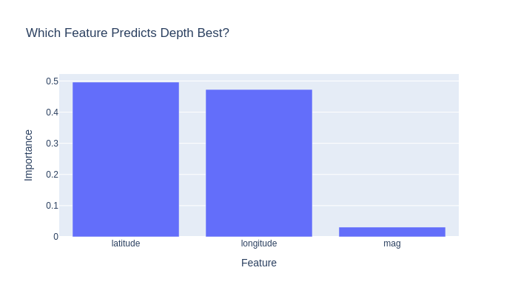
Figure 9: Feature importance of the Random Forest
- Latitude (0.496) and longitude (0.473) account for almost all of the importance. Magnitude is only 0.031. This means that whether an earthquake is deep depends on where it happens, not on how strong it is.
- A random 80/20 split can be too optimistic, because aftershocks and neighbouring earthquakes can be in both the training and the test set. So I also ran a time-based test: train on 2000 to 2018 (11,282 earthquakes) and test on 2019 to 2026 (4,099 earthquakes) which the model never saw. It scored 94.2% against a 66.5% baseline, so the result holds on new data.

8. Insights and Portfolio Pieces
- One question, three tools: SQL answered "how many and which", Plotly answered "where and when", and scikit-learn answered "which groups exist and what predicts depth". Using all three on the same data made it easy to cross-check results, for example the 2005 spike appeared in SQL (+1,423), in the stacked chart, and in the year-by-country numbers.
- Earthquake behaviour is mainly about geography. The zones, the heatmap and the model all say the same thing: location explains most of the pattern, and the same belts stay active year after year.
- Looking at data from several angles caught problems that one tool alone would not. The SQL cross-check found two mislabelled records and a boundary issue in the strength classes, and the box plot revealed the default depth values.
The portfolio pieces from this task are: (1) a SQL analysis of 8 queries including window functions, (2) a set of 6 interactive Plotly charts including an animated map, and (3) a machine learning pipeline with clustering and a model comparison against a baseline, with an honest time-based test.

9. Limitations
- The depth model uses location to predict depth. It does not predict when or where the next earthquake will happen, and it should not be used that way.
- Many depth values are default values (29.0% are exactly 10.0 km, 4.3% are exactly 33.0 km), so depth results are approximate. The 70 km line for 'deep' is a choice I made, and a different line would give different numbers.
- A random train and test split can be optimistic because of aftershocks. The time-based test is more reliable, but a spatial test (leaving out a whole region) would be stricter still, and I did not run it.
- KMeans uses straight-line distance on degrees and ignores the curve of the Earth. It needs me to pick k, and the zone names are my own interpretation.
- The data only includes earthquakes of magnitude 4 and above in a rectangular region, with the same limits as in Task 3 (mixed magnitude types, region not following country borders, 2026 is a partial year).
- SQLite runs here in memory on a small dataset. On larger data, a server database such as PostgreSQL would be used.
- The Plotly charts are interactive in Google Colab. Some viewers, including the GitHub notebook preview, may show them as blank, so I included static images in this report.

10. Conclusion
In this task I used SQL, Plotly and scikit-learn on a real earthquake dataset. I wrote 8 SQL queries with window functions, built 6 interactive charts including an animated map, grouped 15,381 earthquakes into 6 seismic zones, and trained a Random Forest that identifies deep earthquakes with 94.5% accuracy, which I tested against a baseline and on future years. I also found and corrected two labelling problems through cross-checking, and I noted the limits of each method. The project shows that I can choose the right tool for each question and explain the result honestly.

11. Source and GitHub Link
- Data: USGS Earthquake Catalog, https://earthquake.usgs.gov/fdsnws/event/1/ (cleaned in Task 3).
- Tools: Python, SQLite, Pandas, NumPy, Plotly, scikit-learn, Google Colab.
- GitHub folder:
- https://github.com/Santoshgutte1522/data-engineer-internship/tree/main/Task4_Tool_Mastery
- The folder contains the notebook, this report and a README. The data files are in the Task3_Earthquake_Analysis folder.

